**CHAPTER 1: INTRODUCTION**

**1.1 Topic of the System**

**Title: -** “Smart City”

**About Project:**

Every time we travel to a new place, a city guide is a necessity. It both saves time and provides us with useful knowledge about the city. Our project established a web-based city guide platform that enables users to search every location in the city without the assistance of a human guide. You may look up popular locations in a city and learn about its social and political climate, as well as its culture, security, and entertainment options, as well as its businesses, lodging options, and employment opportunities. Services offered to users who have registered on the site are the primary goal of this project. The services pertaining to bus routes, business company profiles, political, historical, and traditional locations in the city.

**1.2 Project Abstract**

The name of our project is "SMART CITY," a website-based application that is used to store information about a specific city and benefits all users who merely visit our website. The website provides comprehensive information about a certain city, including tourist attractions, route maps, business environments, job boards, details on current organizations, hospitality, and the city's overall history. Anyone with a basic understanding of the internet can utilize this website. All users will initially be regarded as anonymous users; however, if they require any services, they will subsequently be regarded as registered users.

The background of every single criterion is included in the overall description. Additionally, it explains how each function is utilized. It explains the architecture design and outlines our assumptions and dependencies. In addition to supporting additional requirements not related to the actor being used, it also supports particular requirements and functional requirements. Appendices and an index are also included. Additionally, it clarifies any doubts or questions. The Handicraft Company's customers and staff can use this system as an application to handle the product information. Customers should be able to log in and upload any necessary product information. Customers and company representatives who log in may access and search any product-related information.

**1.3 Target User:**

Whensoever some merchandise is planning to be made there is constantly a backdrop learning on the destination users. This while we are majorly targeting tourists, new person coming for job. This web portal is being designed for all the users who want to explore new places, hotels, restaurants, or seeking jobs in specialized industries, and many more. As visiting new places without generalized information about the cities, sometimes makes thing hard. As in case of emergency, a new person who had just shifted to a new city will face several issues like finding appropriate hospitals, nursing homes, clinics, medical store, hotels, restaurants. So, we are proposing a web portal system to overcome this undirected problem to all those users who face this situation.

## 1.4 Topic Background:

We all know how important the internet is to each individual's life, and that everything in this world is changing as a result of technological advancements. Computers were a key component of computing at the dawn of the modern era, but as technology advanced, everything changed and the computers evolved into workstations, supercomputers, and other forms. Later, mobile technology was developed, and now everything is mobile. Mobility simplifies everything. Utilization of mobile devices has dramatically expanded over the past two decades, making daily tasks easier to complete. Wireless networks have also taken over the world as a result of the development of wireless technologies. Nowadays, it is simple and reliable to conduct business and financial activities at anytime and anyplace. With the help of the Net, acquaintances may be made with nearly any device, wherever in the world, and they can exchange obligatory info.

## 1.5 Problem Context:

We prerequisite to connect and speed up our subsists with the aid of info and expertise in the age of computers. We all need certain available amenities that don't require much exertion or human involvement. Web phones can ease the stress of customers standing in line while they book any kind of ticket. The current system also grieves from a nonexistence of services and research. Our work has become largely mobile because of the time period we are in. the creation and completion of more user-friendly, successful mobile web applications.

As visiting new places without generalized information about the cities, sometimes makes thing hard. As in case of emergency, a new person who had just shifted to a new city will face several issues like finding appropriate hospitals, nursing homes, clinics, medical store, hotels, restaurants. So, we are proposing a web portal system to overcome this undirected problem to all those users who face this situation.

## 1.6 Rationale behind the System: Why do we need this System?

The investigator has chosen to build an application that will concentrate on subscription answers for the aforesaid issues because the complications that are clue need to be reasoned.

**1.7 Objective of Proposed System:**

The Propound System offers online information on the unique city you're visiting. Additionally, it offers registered users additional services. The following steps in the development of this new system attempt to automate the entire process while maintaining the avenue for database concretion in mind.

* User fellowship is as long as in the submission with diverse controls as long as by system Rich User Interface.
* It can be admittance over the Intranet.
* The city information files can be stockpiled in consolidate or organized database which can be continue by the system.

### **1.8** **Learning Objectives**

The recommended approach will empower the developer to gain pertinent acquaintance and perceptions in the construction of specialized web-based software and tool. Instead of placing a strong emphasis on well-trained competence, the objectives place a lax emphasis on notions and ideas. To build vastly refillable, high-quality software on plan, the designer would need to go through numerous phases of software development, project management, human computer interface, usability aspects, and other related topics. However, the main goalmouth of using mobile computing principles is to boost favored output with client gratification in less time and determination to find an easy solution for booking tickets online and minimize all the efforts that are needed for receiving tickets offline.

The succeeding points listed below are of prime importance to the developer: -

* Learn about XML, web technologies, and mobile web development.
* Acquiring knowledge of the ideas behind services like web services and location-based services.
* Acquiring knowledge in the creation and management of mobile database-based software.
* Knowledge of data assembling techniques and their practical use.
* A deeper comprehension of project management fundamentals, such as work breakdown structures, budgeting, and cost estimation.
* MySQL Query Training and Practice.
* JSP-servlet and Android practice and education.

**CHAPTER 2: PROBLEM DESCRIPTION**

**2.1 Purpose of the Project:**

Services offered to customers who have registered on the website are the primary goal of this project. services related to municipal politics, history, common locations, transit routes, business company profiles, and employment components. A web-based solution called "Smart City" is used to save information about a specific city and benefits all people who merely visit our website. Additionally, this website offers all the services, such as hotel reservations for travelers, ticket reservations, transportation facility provision, business-related information, marketing data, city news, and shop information. The website provides comprehensive info about a certain city, including tourist attractions, route maps, business information, job listings, details on organizations that offer transportation, hospitality, and the city's overall history.

It fosters discussion via chat, polls, and email between users, subject-matter specialists, and the general public. The users would undoubtedly benefit from this because it will save them significant time that cannot be replaced and is also financially sensible. Everyone who wishes to use the system is given a registration form. Depending on the users, this can be categorized. It offers different registration forms for various categories. When students want to download any materials or learn more about coaching centers and colleges, when businesspeople want to learn more about any type of business, when tourists want to learn more about hospitality services, and when job seekers want to learn more about open positions, they must provide their ID and password for security.

**2.2 Existing System:**

In the current, a guest to a particular city must either enlist the assistance of a local resident or ask someone who already resides there for information. putting together all the data you'll want to visit the city. It takes a lot of effort and preparation to do this. We must visit the assistance desk in order to obtain each piece of information.

**2.2.1 Limitations of Existing System:**

• A manual system is the one that has survived. In this case, the city information needs to be saved on disc drives or in the form of excel sheets.

If the data is stored on paper or disc devices, sharing is not possible.

The manual system has a limited user-friendliness and provides us with very little protection for preserving data; some data may be lost due to mismanagement.

**2.3 Proposed System:**

The recommended System offers online data about the specific city being visited. Additionally, it offers registered users additional services. The following activities are included in the creation of this new system and attempt to automate the continuous process while taking database integration strategy into consideration.

• The system makes overall project management considerably easy and versatile by offering a variety of controls through a Rich User Interface in the application.

• The Intranet can be used to access it.

• A consolidated database that the system can maintain can hold the city information files.

## 2.4 Nature of Challenge

### **2.4.1 Domain Challenge**

The developer will have to face many difficulties during the development of this system, some of the major challenges are:

* **Mobile Commerce**: To create a mobile application based on the concept and concepts related to mobile commerce.
* **Synchronization:** Employing the idea of web amenities to interface with the database (API) in demand to agree with the application to acquire the pertinent data would be the main obstacle in creating this website.
* **Interaction Principles:** To comprehend the underlying tenet of how people interact with mobile devices, and to create the application while implementing all those principles that will support the application's successful completion.

### **2.4.2 Technical Challenge**

During the working upon the proposed system, the technical challenges come on the way of the developers are given below:

* **Web Platform:** Firstly, I would like to talk about the knowledge of web platform. As we are going to develop this system based on web platform and we are new to this technology, and yes, we are learning it but there is a need of many concepts of web for the successful development of the project
* **Combining Variety of Modules:** It is going to be very challenging to combine variety of modules like GPS location, Web Services, Database Integration (API), Save Image and much more things in one phase.
* **Server-Client Services**: As the internet needs to communicate with the far fledge database that allows you to sync with the utility to fetch the applicable records. Hence the developer should want to have deep skill of an internet provider because it will often be used to fetch records from or in shape records to far-flung record.
* **Hardware Fragmentation**: There are countless different types of web devices, each with a unique set of capabilities like as RAM, CPU speed, and graphics quality. Fragmentation on the OS level is a possibility.
* **Web Services** As the internet needs to link with the far-flung database that allows you to synchronize with the utility to get the applicable records. Hence the developer should want to have profound skill of an internet provider because it will often be used to fetch records from or in shape records to far-flung record.

## 2.5 Feasibility Study

A feasibility study surveys and gauges a system to see that it is technically, money-wise, untimely, and viable practicable. The cause of a feasibility has a look at for an undertaking is to decide whether or not the proposed undertaking may be evolved with inside the time allotted, with the sources accessible, and in the finances allotted. Succeeding the completion of the feasibility have a look at, the choice is madeeven ifor now no longer to ensue with the project. The feasibility study can be written off as into succeeding four portions:

Technical Feasibility

Economic Feasibility

Scheduled Feasibility

Operational Feasibility

### **2.5.1 Technical Feasibility**

Technical feasibility testing is done to determine whether a project is possible given the resources at hand. The project's technical requirements and the technical resources needed for its organized and successful execution are taken into account while determining the technical feasibility. The following list contains the precise technical resources that must be available to successfully complete the project:

Hardware Resources

|  |  |
| --- | --- |
| **S. No.** | **Hardware Resources** |
| **1** | Processor i5 |
| **2** | RAM- 8 GB DDR4 Memory |
| **3** | Monitor – Any standard monitor |
| **4** | Keyboard, Pen drive, Mouse etc. |
| **5** | System Type- 64-bit OS |
| **6** | Hard drive – Equals to 1 TB HDD and 128 SSD |
| **7** | Accessories – Internet connection. |

Table 6: Hardware Resources

Software Resources

|  |  |
| --- | --- |
| **S. No.** | **Software Resources** |
| **1** | Visual Studio |
| **2** | JDK(IntelliJ) |
| **3** | Chrome, Firefox. |
| **4** | Database- Firebase |
| **5 OS** (Mobile phone)- Android OS | |

**6 OS**  (PC)- Window 10

|  |  |
| --- | --- |
| **7** | Case tools: Microsoft Visio |

8 Documentation Tool- Microsoft words 2010

Table 7: Software Resources

Resources of Execution

|  |  |
| --- | --- |
| **S. No.** | **Resources for Execution** |
| **1** | OS - Android 10.0 |
| **2** | Android Smartphone - GPS enabled mobile phone, |
| **3** | CPU: 500nMHZ |
| **4** | RAM- 90 MB |
| **5** | Disk Space: 70 MB |

**6** Good internet connection

### **2.5.2 Economic Feasibility**

An economic feasibility study's goal is to figure out the commercial benefits and costs of a project's development. The project is regarded efficiently practicable if the projected profit equals or exceeds the system's expected costs. Considering that the suggested system development environment was created using an open-source platform for the web, the development phase will require less expenditure. Furthermore, any piece of software or program that is developed must be investigated, which may be terminate for a low cost. The only outlay required decree be for a corporal device to investigate the system.

**2.5.3 Schedule Feasibility**

Assessing whether a project can be completed on time, as specified by the Gantt chart, is the main objective of project feasibility analysis. The project must be finished on time and according to schedule because each step has a deadline. If the project can be finished on time, its scheduled feasibility is high. A project managing device that can be used to assess if a project is on track is the Gantt chart. A Gantt chart is used to effectively succeed time for each job over the application's proposed 38-week timeline.

**2.5.4 Operational Feasibility**

Operational feasibility measures how well the proposed system responds to concerns raised in the project's early phases, as well as how the project intends to fulfil the conditions itemized in scope classification and take advantage of opportunities identified during scope classification. Given that the project's main objective is to address the challenges that individuals face in today's environment, it will undoubtedly be operationally feasible.

## 2.6 Conclusion

Chapter 2 discusses the obstacles identified in the ongoing research topic, especially environmental challenges. The developer has taken into account every problem that a typical user can encounter. The problems have been recorded, along with the causes of each problem/anomaly. The developer's ensuing goalmouth was to offer appropriate fixes for all of the found abnormalities. Each anomaly's resolution and explanation have both been recorded for this reason. The system is then put through a feasibility analysis to see if it is technically, operationally, and commercially feasible and will be finished in a specific amount of time.

# **CHAPTER 3: LITERATURE REVIEW**

## 3.1 Introduction to Literature Review

Literature review is a portrayal of already work done by other researcher’s interrelated to this ongoing problem. It is based on published books, journals, and other research papers and it is considered as starting point for ongoing study. Following objectives of literary review are listed below: -

* To do an efficient analysis of beforehand finalized research in direction to regulate their perceptions, domains, weaknesses, and methodologies.
* Review the findings and suggestions of others to see if there are any existing proposals connected to the subject.
* To provide answers to some questions and clear up any mix-ups about the continuing matter.

### **3.2 Academic Research**

#### In order to ascertain the genuine demand for this application and its advantages for the general public, the developer conducted academic research before developing the suggested system by reading research papers, journals, and other sources. How users will profit from it Additionally, it will verify the developer's work in optimizing the system's operation.

#### **3.2.1 Software Methodology and Software Engineering Concepts**

In directive to produce a user-delighted system on plan, the developer requirement deportment investigate on the finest manner for programmers.

#### **3.2.2 Human Computer Interaction Principles**

#### A good design, evaluation, useable interface, etc., that is user-friendly with conspicuousness, working, etc., are absolutely necessary. To ensure that the web application is created with the implementation of all those criteria that will justify its successful completion, the developer must be knowledgeable of the interaction principles between humans and technological equipment.

#### **3.2.3 Project Management Principles**

For the system to successfully complete the development, project management presumptions such scheduling, feasibility, and risk analysis will be considered.

### ** Books**

### **Topic Book Referred**

|  |  |
| --- | --- |
| **Software Development**  **Life Cycle** | Camel in Action by Clause Ibsen and Jonathan Anstey  Peopleware: Productive Projects and Teams by Tom DeMarco and Timothy Lister  Design Patterns: Elements of Reusable Object-Oriented Software by Erich Gamma, Richard Helm, Ralph Johnson, John Vlissides, Grady Booch |

*Pragmatic Programmer* by Andrew Hunt and David Thomas

**Web Development**  Introducing web developmen**t**by Jorg Krause

Web coding and development by Paul MacFedries

|  |  |  |
| --- | --- | --- |
| **Human Computer**  **Interaction Principles** | Dix, A., Finlay, J., Abowd, G. and Beale, R.  *Human computer interaction*. Harlow, England:  Pearson/Prentice-Hall.  Human Computer Interaction- Alend Dix, Janet Finlay,  Gregory  D. Abowd, Russell Beale | (2004). |
|  |  |  |

**Features of OOPS** Steven Holzner et al. (2007). Java2 Programming Black Book.

Table 9: Books References for Academic Research

## 3.3 Domain Research

Domain research is crucial because the project will take on different forms depending on the situation. Once this is done for a particular constituent, we can go on to the analysis and design of that constituent to assure its usability. The researcher discovered during the research procedure that customers have numerous problems when travelling to any city.

Web-based applications and mobile computing are the application's domain areas. The researcher must use technology to ease user issues to get a full understanding of user requirements and important system components.

### **3.3.1 Web**

The World Wide Web, a serving of the Net that consists of pages that can be accessed by a Web browser, is more commonly referred to as the "Web." The Web and the Internet are frequently used interchangeably because of this presumption. The global server network that enables information sharing on the Web is actually referred to by the word "Internet." Therefore, even though a sizable amount of the Internet is made up of the Web, they are not the same thing.

**3.3.2 Web Architecture**

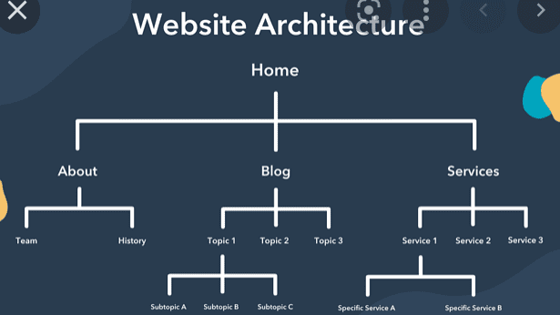

**3.3.3 Website Framework**

 A group of resources and tools that are available to software and web developers are referred to as web development or web application frameworks. These frameworks enable web developers to create and maintain websites, web services, and web applications.

## 3.4 Market Review

The website can be used as a ample guider software package because it has three user interfaces (user or consumer, dispatcher, and admin or service provider), each with its own set of functions.

We're continually watching and assessing this critical pandemic's direct and indirect consequences, keeping COVID-19's unknowns in mind we are unable to communicate with others.

## 3.5 Critical Evaluation of Literature Review

The growth of this Website for users is investigate in directive to regulate that what functionalities are desired by the end users for the improvement of this web.. The systems that are like to planned system have been observed to offer a baseline to application and what features are difficult to implement and what challenges might be encountered by the developer.

## 3.6 Critical Evaluation of Market Review

We get to know from the conducted researches, that this kind of application is currently available in the market or not. According to the above system, some websites similar to this are available in the market. Although the same applications have verified to be extremely useful in the real world, and the complete study aids the developer in gaining an enhanced grasp of how to create the entire website.

## 3.7 Critical Success Factor

The proposed system would provide users with important features like remote database backup, push notifications, payment options, online delivery, and many more. The developer must succeed all of the highlight discovered during the literature study; secondary research that must be executed I to carry an efficacious structure to the end-user**.**

## 3.8 Conclusion

The third chapter looks back at previous research to handover an experience for the future project. Existing systems were researched as part of the literature review to achieve experience in the study's subject; what functionalities are new on the system, and what functionalities the developer could commingle to this new system. The chapter also discusses the data and sources that were gathered as part of the literature study and are being studied or will be looked at in the forthcoming to gather data and info on this project's topic.

# **CHAPTER 4: RESEARCH METHODS**

## 4.1 Primary Research

* Primary research is defined as the first-ever collection of data or information on the topic matter from the real world. By directly addressing such inquiries to scene users and calculating their answers, it is done to minimize the developers' hesitation and doubt that arose as a outcome of secondary research. The project's developer can use this learning to advance project development. An interview and a questionnaire, both of which are described below, are the developers' two main research techniques: Reasons behind the questionnaire's creation:
* Because there are so many potential users of the system, it is not feasible to get in touch with each one of them individually to collect their feedback.
* This allows reach to many people simultaneously regardless of their geographical location, which saves more time.
* Because it is possible to use statistical techniques, the analysis of the questionnaire is more accurate because it is done in the form of graphs and charts.
* Users have the option of providing answers in secret, increasing the likelihood of receiving needs that are exact.

### **Questionnaire for Customer**

### Respected Sir/Mam,

First and foremost, thank you for taking the time to participate in our survey. This survey inquiries about your buying online dairy goods experience as well as your attitudes toward online dairy goods.

The researcher is a 3rd year student of **College Panipat Institute of Engineering and Technology** pursuing B tech in **Computer Science and Engineering**. For the 3rd year project, primary research effort and data collection is done through a survey. The researchers’ kindly requests that you take few minutes to read over the questions and assist us in completing this survey by answering the questions below. The questions were carefully crafted while adhering to all of **Kurukshetra University's** ethical norms for study.

The title of the project is “**SMART CITY**”. The goal of this inspection is to help the people and tourists by providing information about Hotels, Restaurants, Schools, Colleges, Police Station, Famous Place, Ancient Place, Industries, etc.

This survey will assist the developer in learning about the user's various preferences and improving the ongoing accessible system. The findings of this assessment will be quite valuable in obtaining the required information for designing a web application.

### Instruction

This component of the questionnaire will assist the researcher in estimating project study outputs.

It is critical that you thoroughly answer all pertinent questions.

Section A: - This part contains your personal and professional information, and it is optional.

Section B: - Select the response that best satisfies the requirements for the question below. You may select more than one response.

. Section C: - Please feel free to give your thoughts/ideas and assist the researcher in understanding the essential requirements.

### **Disclaimer**

Your responses to this inspection, as well as any specific questions, are entirely private. Your identity will be kept private, and the information you provide will only be used geometric reasons.

**SECTION**

**A**

**Age**



**Gender**



**Profession**

**_____________________________**

**Qualification**

**_____________________________**

SECTION

**B**

**Question**

**1**

**Do**

**you**

**own**

**an**

**Android**

**Smartphone?**



**Justification**

This

question

will

help

the

investigator

to

examine

the

availability

of

smartphones

ong

the

target

audience

so

that

the

researcher

can

analyze

the

target

audience

app

with

N

**If**

**yes,**

**then**

**Question**

**2**

**Which**

**version**

**of**

**Android**

**Operating**

**System**

**does**

**your**

**smartphone**

**support?**



|  |  |  |  |  |  |  |  |
| --- | --- | --- | --- | --- | --- | --- | --- |
|  | |  | | | | | |
| **Justification** | | The aforementioned query will aid researchers in their analysis of the smartphone compatibility problems. in order for the researcher to consider adding cutting-edge functionality to the application. | | | | | |
| **Question 3** | | **What types of reports do you require in the app?** | | | | | |
|  | | Daily Report Weekly Report  Monthly Report Half-Yearly Report  Yearly Report All of the above  If other, please specify: **…………………………** | | | | | |
| **Justification** | | This query will inform the researcher about the preferred types of reports by the audience. | | | | | |
| **Question 4** | | Which report format would work best for you?  PDF Report Graphical Report (Charts) Other  If other, please specify: **…………………………** | | | | | |
| **Question 5** | **If yes, where would you like to perform the backup?**  SD Card Cloud Storage Other  If other, please specify**…………………………….** | | | | | |
|  |
| **Question 6** | What are the fundamental details you must know in order to search anywhere? | | | | | |
|  | | **Information** | **Yes** | **No** |  |
| Name |  |  |
| Address |  |  |
| Contact |  |  |
|  |  |  |
|  | Any | | other information, please specify**………………………….** |  |  |  |
|  |  | |  |  |  |  |
| other information, please specify**………………………….** | | |
| **Justification** | This will provide the designer with information about the data that has to be fetched for a specific module. | | | | | |
| **Question 7** |  | | | | | |
| **Justification** |  | | | | | |

Table 11: Questionnaire for Developer

|  |
| --- |
| **SECTION C** |
| **Additional Requirements:**  ..............................................................................................................................................................  ..............................................................................................................................................................  .............................................................................................................................................................. ..............................................................................................................................................................  ...........................................................  Any Suggestions: |

..............................................................................................................................................................

..............................................................................................................................................................

..............................................................................................................................................................

.............................................................................................................................................................. .............................................................................................................................................................. ..............................................................

### We appreciate your assistance and the helpful information you provided. We appreciate your support and attention. Please check to make sure you answered every question on the feedback form. Once fully finished, kindly deposit or send the feedback form to the researcher.

### **Interview**

### A face-to-face interview is a primary research technique in which the respondent is asked a series of questions from a prepared list. The vast bulk of the inquiries are unstructured. It is designed to gather a lot of data about a certain topic. Interviews for the proposed system include questions that call for a brief explanation of the requirement in order to fully understand it. The interviewees for the suggested system are developers. In order to learn as much as possible about the needs of the system, it was important to get a distinctive viewpoint from the users.

### **Justification for Conducting Interview**

* It delivers first-hand information, increasing the likelihood of obtaining accurate facts and high-quality data, as well as new visions and suppositions.
* It will aid in the congregation of thorough information regarding the projected system's functionality, as it is superlative for examining problems.
* A person's sentiments, ideas, and actions can be observed in addition to what they say, allowing the interviewer to confirm whether what they are discussing is correct or incorrect.

### **Interview Questions for Developers**

|  |
| --- |
| **Which system would you like to prefer for using this website, and why?**  ...........................................................................................................................................................  ........................................................................................................................................................... ........................................................................................................................................................... ...............................  **Justification: This will enable the developer to comprehend the user's perspective, such as if the user wishes to adopt new technologies quickly or take their time. Most of the questions that the user has marked as useful will be useful if they respond to the mobile application.** |
| **1. What do you do to store data? What will happen if the data will be lost?**  **.** ........................................................................................................................................................... ........................................................................................................................................................... ........................................................................................................................................................... ...............................  **Justification:** This question will assist the researcher in comprehending the requirement for the cloud to store data online. |
| **2. Did you think that using this system will help you if yes please specify. your ans.?**  ...........................................................................................................................................................  ........................................................................................................................................................... ........................................................................................................................................................... .............................  **Justification:** This question will explain how this system is going to be useful for you. So, that it is clear how it will helpful. |

**3.What level of backup efficiency can be achieved when using cloud computing and email for data backup?.**..........................................................................................................................................................

........................................................................................................................................................... ........................................................................................................................................................... ..................

**Justification:** The developer is curious as to whether the backup provided by the cloud is adequate to satisfy the standard's efficiency requirements. Both scenarios rate the data backup, but the recommended system is more beneficial**.**

|  |
| --- |
| **4. What are the potential issues that may arise throughout the application's development. phase?**  **.**..........................................................................................................................................................  ........................................................................................................................................................... ........................................................................................................................................................... ..........................................................................  **Justification:** The developer wants to recognize whether there are any potential flaws or mishaps that could obstruct the development process. If there is any technology, there is a risk that it has already happened and is obstructing the development process. |
| **5. Have you had any issues with the software? If so, what are the issues?**  **.**........................................................................................................................................................... ........................................................................................................................................................... ...........................................................................................................................................................  ............................. |
| **Justification:** Its response will help identify the problems merchants are having with the current software so that those problems can be fixed in the suggested system. |

Table 12: Interview question for developer

**4.2 Secondary Research**

Past to completing main research, secondary research is commonly commenced. For this, it is necessary to acquire independently verified data from beforehand published books, journals, and research articles. Because it is desirable to do so and save time over continuously making the same error, it is done to learn from other people's faults in the pertinent sector.

**4.2.1 Technical Research**

The platform, programming language, database, technology, and technique are examples of technical aspects of the research. Technical research is conducted before the system design and implementation phase of the proposed project since it is an essential component that can influence the project's implementation. It is decided which platforms, programming languages, databases, technologies, and processes will be used for the particular project after a thorough analysis and evaluation of all available options.

### **Justification for Choosing Website as a Platform**

The developer's verdict to use one platform over another has continuously been a grim one. Because each platform has its own set of advantages and disadvantages, it is impossible to declare that one is superior to the others. Let's look at why Android is favored over other operating systems.

**What is Website?**

A website or site is a collection of linked web pages that may be accessed by using the browser to navigate to the website's home page. For instance, https://www.computerhope.com is the URL (Uniform Resource Locator) for the Computer Hope website. From the home page, you can view any of the webpages on our website, including this one.

**Why Website?**

For the creation of the application, the researcher chose to work with Android technology for the following reasons:

* **Huge Market:** Android has a share of 82.8 percent of the smart phone market, according to IDC Research, Inc. (2015). Because this technology is so widely used in the market, the researcher thinks that if a development is based on it and made Android-compatible, the success rate would be high.

|  |  |  |  |  |  |
| --- | --- | --- | --- | --- | --- |
| **Period** | **Android** | **iOS** | **Windows Phone** | **BlackBerry**  **OS** | **Others** |
| **2016** | 90% | 7% | 2% | 0.6% | 0.4 |
| **2015** | 82.8% | 13.9% | 2.6% | 0.3% | 0.4% |
| |  | | --- | | **2014** | | **2013** | | **2012** | | |  | | --- | | 84.8% | | 79.8% | | 69.3% | | |  | | --- | | 11.6% | | 12.9% | | 16.6% | | |  | | --- | | 2.5% | | 3.4% | | 3.1% | | |  | | --- | | 0.5% | | 2.8% | | 4.9% | | |  | | --- | | 0.7% | | 1.2% | | 6.1% | |

Table 13: OS Smartphone Share

* **Code Reusability Using Website Reuse Models:** Even Compound system have been made easily and rapidly using Website due to Website platform give permission reuse of code by providing **different Website Reuse Models**. This will help in improving developers’ time and improve quality of system.
* **Rich Development Environment: Website** has well of app development surrounding which enable easy way of developing much eye-caching app easily and in less amount of time. Additionally, it's an excellent option because the application must be submitted within the allotted time frame.
* **Open-Source Architecture:** Since website is an **open-source platform**, less outlay would need to develop this system. Any system or application that is made required have to be checked that could be done without any investment.
* **Justification for programming language selection (Java)**

The developers have to use java language for the development of planned system. Because the system would be developed on the Android platform, which leverages the Java programming language in its development surroundings, it's a no-brainer.

### **Justification for Web Service Selection (WSS)**

Although, android is not able to communicate with remote database by itself. Therefore, there will be need of a bridge between these two and that is web service. WSS will going to be help us to fetch data from data to remote data. REST web service would be implemented to the suggested system application. REST is an architectural framework for networked hypermedia systems that was primarily used to develop scalable, lightweight, and stable Web services.

#### **4.2.2 Development Methodology**

### Software methodology, as shown by (Erickson, 2005), affords a methodical strategy or road map for the effective development of applications. It supports risk reduction, complexity management, and high-standard software development within predetermined budget and schedule limitations. If the development has strayed from the initial design, it could be utilized to track this. The developer had almost all of the accessible practices under consideration in order to choose the best one to meet the project's technical, organizational, and project-related needs. After quickly evaluating and researching several software development methodologies, the developer has decided to adopt "VMODEL" for the project's development.

### **V-model Methodology**

Following a thorough examination of various software methodologies, the developer settled on "V-MODEL" as the best fit for the project's objectives. Improvements to the system could be made at a reasonable cost due to the frequency with which new increments will produced. Modifications can be discussed based on the feedback, and features can be improved or deleted. This would successfully supply the customer's desired or required finished system. To meet deadlines, this practice divides tasks into smaller time intervals.

### **Phases of V-Model Methodology**

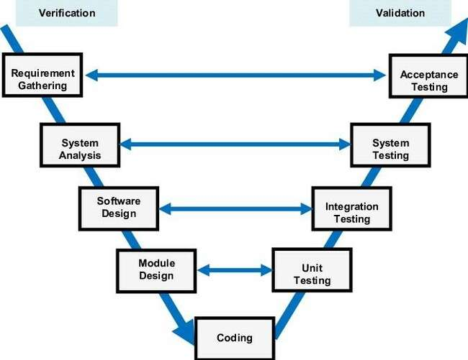

Table 15: phases of V-Model

During the development of the system, developers will follow the following phases.

* **Requirement Gathering**- This is the first step in the verification process. At this point, the developer was not arguing the system's development process; rather, they were having a general discussion with a document outlining user demands. The function, performance, security, data, and interface of the system would all be covered in this article.
* **Software Design-** At this point, the likely design of the product was expressed. It was written keeping in mind the necessary summaries. Additionally, the developer is informed and changes are scheduled as a result if anything improper in the design is discovered while studying the documentation.
* **Architecture Design-** Before combining the modules, it's crucial to comprehend how they work.
* **Module Design**- At this point, the architectural strategy is broken down crazy about smaller parts so that each one can be planned and described separately. The components of the system are called modules. The programmer is able to decipher it disjointedly.

### **The Validation Phases of the V model**

* **Unit Testing-** It is created during the segment strategy stage and applied to the code during the validation stage. Although it helps in the early detection of issues, unit testing does not catch every flaw. Unit testing is code-level testing.
* **Interface Testing**- It has to deal with the process of architectural enterprise. Incorporation trials are used to ensure that the system's internal modules exist and communicate with one another. To put it another way, in this step, the individual entities will be tested together to uncover interface issue.
* **System Testing-** It will be directly related to the stage of software design. It looks at how the entire system functions as well as how the system declares itself in respect to other systems. Additionally, the enormous mainstream of hardware and software compatibility problems could be found while system testing.
* **Acceptance Testing-** Putting the product through its paces in a real-world setting is a step in the business requirement analysis process known as acceptance testing. It showed problems with other structures in the user's environment that were incompatible. Receiving testing also finds non-functional problems, such load and concert problems, in the authentic user situation.
* **Release testing-** A decision must now be made regarding whether the developed product or programmed is appropriate for the end handler.

### **Justification for choosing V-Model**

The developer decides to use the Waterfall Model for the development of this system. V-Model selection is predisposed primarily by-

* **Stable project requirements:** It establishes a set of constant project necessities because the majority of user necessities in our project would be restricted at the time of PSF, and the Waterfall technique fully supports a project with established necessities.
* **Progress of system is measurable:** It creates paperwork following each phase, and because our third-year project is structured in this way, we must succumb paperwork following each stage in directive for it to be most appropriate.
* **Strict sign-off requirements:** Since the developer's goalmouth is to satisfy the user, this process will work best since the developer will offer the customer's chosen functionality and features up until the user is completely satisfied.
* Prior to creating a single line of code, necessities and enterprise are emphasized, which saves time and effort and lowers the risk of plan slippage or failing to meet end user expectations.
* In a modified waterfall model, life cycle phases can be overlaid. The modified waterfall paradigm for software engineering provides more versatility because the phases overlap. Multiple jobs can be completed simultaneously in the interim, certifying that software faults are discovered premature in the progress cycle and that the charge of correcting the product is kept to a minimum.
* **4.2.3 Development Plan**

|  |  |  |  |  |  |  |
| --- | --- | --- | --- | --- | --- | --- |
| Total  Duration | 14 weeks | Start Date | | 20 March,  2022 | End Date | 25 June, 2022 |
| **PHASE AND**  **DURATION** | |  | **Tasks** | |  |  |
| **PROJECT DEFINITION** | |  | Idea Generation | |  |  |

|  |  |  |  |  |  |
| --- | --- | --- | --- | --- | --- |
| *Duration: 1 week* | •  •  • | | Draft Project Proposal Project Title Selection Abstract  Form for Project Proposal | | |
| PROJECT PLANING  *Duration: 1 week* | •  •  • | | Work Breakdown Structure  Scheduled and Time Estimation  Ghantt Chart | |
| REQUIREMENT ANALYSIS  *Duration: 2 weeks* | | | ➢ **Define and Finalize Requirement Specification**  Background of the Project Context of the Problem User Prerequisites  » Establish Goals  » Determine the Project's Scope  » Features and Functionalities.  **Organizing Project Specification Form**   * **Research and Analysis**   » **Research**   * + Academic Research   + Secondary Research   + Human Computer Interaction   » **Analysis**   * + Domain Analysis   + Existing System Analysis | |
|  | | | * User Requirements * User Profiling and Modelling * Risk Analysis | | |
| SYSTEM DESIGN  *Duration: 5 days* | | | * **Navigational Design**   » Storyboarding   * **Abstract Interface Design**   » Mobile Application Architecture  » Functionality Design  » Interactivity Design   * **Design for Test Plan**   » Acceptance Test  » System Test  » Interface Test | | |
| PROTOTYPING  *Duration: 1 week* | | | Creating Prototypes  ➢ Evaluate Prototype feedbacks | | |
| PRODUCTION AND  IMPLEMENTATION  *Duration: 2 weeks* | | | * The construction and integration of modules, the integration of the backend and front end, the implementation of a functioning system, and the midpoint interview | | |
| TESTING &  EVALUATION  *Duration: 7 weeks* | | | * Test plans, unit testing, integration testing, system testing, critical evaluation, prototyping evaluation | | |
| PROJECT ENDING  *Duration: 2 days* | | | ➢ Submission of the finished product | | |

Table 16: Development Plan

## 4.3 Conclusion

The explore methodology is the main topic of Chapter 4. The investigator conducted primary and secondary research as well as technical study in order to make a ultimate supposition concerning the user needs, technologies, and tools to be used. A diversity of methods, including surveys and interviews, were used by the researcher. The inquiry was mandatory to prevent homicide time far ahead in the development phase. With this information, the researcher may now decide with confidence regarding the features of the system and any prospective issues. After performing widespread investigate on the topic, technology, language, and tools, the developer is self-assured plentiful to put the proposed program into practice.

# **CHAPTER 5: ANALYSIS**

## 5.1 Analysis of Questionnaire

Refers to appendix

### **5.1.1 Overall Conclusion of Questionnaire**

### Users who included students, service members, and businesspeople received the questionnaires. The developer can better grasp the user's perspective on the problems they encounter while buying a general ticket at the railway counter and how they might be resolved in the rail environment with the use of this type of primary research, which is comparable to a survey. The questionnaire-based poll gave the developer a detailed understanding of what customers want when making online purchases. The developer was able to add the functionality that these users requested as a consequence of their input.

### **5.1.2 Overall Conclusion of Interview**

Obtaining developer input on the intended application was the study's main goal. This kind of research was very helpful to the developer in identifying the problems customers encounter while placing orders for items in offline mode in a railroad context, as well as potential solutions to the problems. The creator of the proposed system was only made aware of the necessary features, benefits, and drawbacks of each segment by the actual end users who would device the system. In order to establish such a system, the developer therefore concentrated on customers who wanted to buy, sell, and buy dairy and other products online.

# **CHAPTER 6: SYSTEM DESIGN**

## 6.1 Introduction

The enterprise process entails transforming user requirements and software apparatuses into a software edge to offer a podium for the system's enactment. System blueprints and physical modelling are produced using software engineering methods and tools.

The proposed system's design phase incorporates the requirements as an input, and the result is a set of implementation guidelines. Three to four strategy foundations for each segment must be generated and supplied as input to the enterprise when the research and analysis stage is finished.

**Entity-Relationship Diagram (ERD):** I The developer will require ER diagrams to identify the entities and relationships between them in order to store the data, which will eventually be turned into tables during the normalization stage.

**6.2 Data Flow Diagram**

**6.2.1 E-R Diagram:**

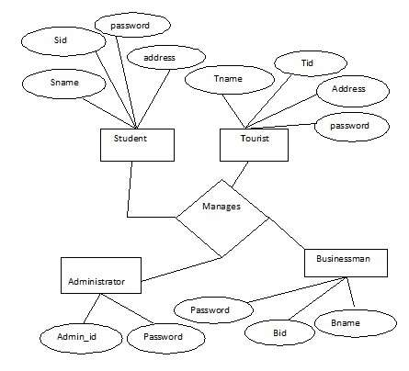

**Figure 6.1 E-R Diagram**

**6.3 Behavioral Diagrams**

**6.3.1 Use Case Diagrams:** Identifying, delineating, and organizing system requirements are all done through the use of use cases in system analysis. The use case consists of a number of potential interactions between users and systems in a specific environment that are connected to a specific objective.

**Fig.6.3.1 Use Case Diagram of the System**

**Description:**

**Name of the Use Case:** City Information

**Description:**

Everyone who visits the website can do so without any barriers and view all the information there.

**Pre-Condition:** No pre ailment exists

**Post condition:** Home Page will be displayed.

**Flow of events:**

Call up the homepage.

Views the pages containing the necessary data.

To register, click the register button.

Sign up for an account to access the necessary services.

**Name of the Use Case:** Reports

**Description:**

Every user can nonstop entree the website and see all information in the reports.

**Pre-Condition:** Click on Reports in home page

**Post condition:** Reports Page will be displayed.

**Flow of events:**

1. I Call up the homepage.
2. Views the reports that the administrator has created. Click on jobs to view jobs.
3. Select "business" **Name of the Use Case:** Services

**Description:**

Only after registering can every user visit the website directly and see all the services.

**Pre-Condition:** First register and Login with user_id and click services button

**Post condition:** select the required service you will.

**Flow of events:**

1. Call up the homepage.
2. Enter your user ID and password to log in.
3. On your home page, click Services.
4. Click the necessary service of your choice.

**6.3.2 Class Diagram:**  In the unified modelling language, a class diagram shows the connections and interdependence between classes in the source code. An object in this sense is a particular entity in a programme or the piece of code that represents that entity, and a class describes the methods and variable quantity in that object.



**6.3.3 Collaboration Diagram:** A collaboration diagram, sometimes referred to as a communication diagram or an interaction diagram, is a depiction of the relationships and connections among software objects in the amalgamated modelling language.



**Fig 6.3.3(a) Collaboration Diagram of the User**



**Fig 6.3.3(b)** **Collaboration for Course Registration**



**Fig 6.2.3(c)** **Admin Update Collaboration Diagram**



**Fig 6.3.3(c)** **Business Person Collaboration Diagram**

**6.3.4 Sequence Diagram**: A sequence diagram is a graphic that displays item interactions in chronological order. It specifically depicts the objects involved in the conversation and the flow of communications**.**



**Fig** 6.3.4**(a)** Sequence **Diagram of the User**



**Fig 6.3.4(b)** **Business Person Sequence Diagram**



**Fig 6.2.4(c)** **Admin Site Update Sequence Diagram**



**Fig 6.3.4(d)** Course **Registration Sequence Diagram**

**6.3.5 Activity Diagram:** Activity diagram describes various activities that takes places given in a particular process. The administrator activity diagram describes how the admin performs various activities in order to provide various services to the different types of users. The user activity sketches out the user's interaction with the system also various services that are accessible by him.



**Fig 6.3.5(a) Administrator activity diagram**



**Fig 6.3.5(b) User Activity Diagram**

**6.4 System Specific Module**

Our project consists of five sections. Below is a list of them along with a brief explanation.

1. Administrator Module
2. Tourist Module
3. Student Module
4. Businessman Module
5. Jobseeker module

**1.Administrator Module:** The admin module is the main segment because it handles the decisive tasks related to site changes, business updates, employment alerts, etc. It keeps track of data for the other four modules. Updates are made to notifications, industries, hotels, resumes, and site information by the different software components in the administrator module. Admin has input all of the historical information, including political and social aspects, and if he so chooses, he may modify the information. Admin enters information about jobs, including job titles, openings, and company profiles, and he has the option to amend that information once it has been submitted.

Admin enters the emergency information, including emergency phone numbers, and when he enters the information, he can update it. He entered information on typical locations, including a description, location, address, and an image of the spot, and he was able to change the information after it had been input. admin entered information about news publications, local channels, and which publications are available in the city; after entering the information, he was able to alter it. Admin input the information on the political leaders, and after he did, he was able to alter it.

**2. Tourist Module:** After registering as a tourist, the user is regarded as an authorized user for the purposes of maintaining information about the city's tourist attractions, hotels, entertainment, etc. The tourist module's numerous software elements include the ability to see theatres, hotels, city maps, ATM locations, hospitals, city histories, travel agencies, and bus routes.

**3.Jobseeker Module:** Because it requires some paid services, the jobseeker module is a commercial module. The job seeker visits the jobs portal to look for open positions. He then sends the administrator his resume. The jobseeker module includes a number of software components that can be accessed, including view jobs, view alerts, see institutes, view city updates, publish a CV, and view city location.

**4.Businessman Module:** The businessman module includes data on the various industries, businesses, and social and political influences of the city and several software elements of the businessman module.

**5. Student Module:** The student module keeps track of a variety of data on the city's educational institutions

The list of the software mechanisms intricate in our project are enlightened below.

a) **View Map:** By rerouting to Google Map, it shows the city map of the specific city and is able to provide a dynamic map.

b) **Insert Alerts:** Database warnings should be included. This is utilized to provide the user with time-to-time alerts.

c)**view Profile:** It displays details about various registered users.

d)**Bu search:** If you enter the source and destination, it will show bus schedule information**.**

e) **view Alerts:** It offers sirens that are kept in a database.

f) **Registration**: offers possibilities for registering for a variety of user categories.

# **CHAPTER 7: IMPLEMENTATION**

## 7.1 Introduction

After the design phase was complete, the source-originator decided that the specified requirements had to follow the proposed system development sequence. During the starting phase, one of the most critical phases of any project, the source-originator would strive to transform the system design into a functioning system, creative tool submission is required during the implementation phase. The programmer chooses to employ the Java programming language and the Android SDK. The implementation process was slowed down by a number of mistakes that the originator had to deal with. The design process is also covered in this chapter.

## 7.2 Tools used for Implementation

All the tools used in the development of the system have been listed by the originator.

|  |  |
| --- | --- |
| **Tools** | **Purpose** |
| **Windows 10** | used as an operating system to run all of the tools listed below for system development. |
| **Microsoft Visio 2010** | To withdraw UMLstructures |
| **Microsoft Word 2010** | To document the project |
| **Microsoft Project 2010** | For preparing Gantt Chart. |
| **Microsoft PowerPoint 2010** | For preparing Presentation slides. |
| **Windows Os 12** | The submission's pages are designed via this tool. |

**Fire Base** Used as a remote database (in the server side).

|  |  |
| --- | --- |
| IntelliJ and VSCode | It is an integrated development environment for java. |

**Table 33: Implementation tools**

**7.3 Implementation Plan**

**7.3.1 Implementation Approach**

This design would give the originator a general idea of the steps taken to create the actual system. To properly complete a system, you'll require a strategic plan. By dividing the system into independent parts, the "divide and conquer strategy" makes it easier to identify and correct problems. The different segments will be prioritized according to their degree of difficulty, with the most complex ones being developed first, to ensure that each is implemented on schedule.

### **7.3.2 Implementation Approach Steps**

1. As this submission consists of three segments: Visitor, dispatcher and service provider or admin. Firstly, Admin phase have to be created first so that user details can be maintained by admin.
2. The very first step is to create a login and registration pages so that everybody can take advantages of this app
3. The second step is to create the forgot password page so that if any user forgets its password, they will be able to recover.
4. We must proceed to the system's user functionality after logging in and registering. The dashboard, which will give users access to different aspects of their segment, must first be developed.
5. Following the creation of the dashboard, we must comprehensive the errands that are reliant.

We can't see the order history, for example, unless we finish the order procedure.

1. After that, we must go to Change Password in order to change his account's password.
2. Next, we have synthesized the admin dashboard page to steer throughout the page.
3. Next, we have created the register user so that user will able to login into the system. After registering the user, we need to first create the dashboard of the throughout the page in order to navigate from one page to another.
4. In order to complete the assignment, we must create the user account functionality after creating the console.
5. After creating all these things, we have to create the admin part, in this we already created the dashboard and the register functionality so we directly move to the next functionality i.e., register user. The independent functionality so we can create this functionality any time.
6. The see all registered user capability must then be created so that we can see every user who has registered with the system.

**CHAPTER 8: KNOCKING**

## 8.1 Introduction

## It is the process of knocking the software through its paces in order to find and resolve issues. The goal of the knocking is to find different kinds of mistakes in the shorassessment amount of time and effort imaginable. To create a technology that is incredibly fulfilling and error-free, a technique that involves study of each segment and capacity is necessary. (Khan & Mustafa, 2007)

## 8.2 Need of Knocking

Verifying and validating the completed system was the purpose of the Knocking phase. It will function in the manner expected in the project Citations, and all the functionalities will function as expected. A originator, as part of the Knocking process, does not have to assessment all sections of code to verify that they are free of errors and bugs. Instead, their objective is to find situations that may adversely affect the system or make the project fail. Hence, Knocking is agreed out to boost the quality of the system so that the intended users are satisfied with it. The highlights of this chapter include:

* Knocking types.
* Knocking duration.
* People involved.
* Errors reported by users.
* In what manner measure were taken.

## 8.3 Assessment Plan

It is usually important to avoid errors, detect and correct software faults that do occur, and foresee steadfastness subsequently growth. To ensure actual and well-organized Knocking and quality guarantee, the Knocking process, performances, and tools are essential. In next section, we will discuss various Knocking techniques that can be implemented foe this system.

### **8.3.1 Knocking Types**

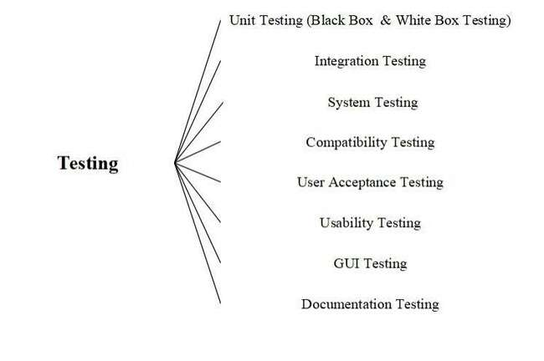Ta Table 38: Knocking Types

|  |  |  |  |
| --- | --- | --- | --- |
| **Serial No.** | **Techniques of Knocking** | **Specifications** | |
|  | **Unit Knocking** |  | Unit Knocking examines individual software segments or components. |

|  |  |  |
| --- | --- | --- |
|  |  | system. Since it must be performed by programmers with detailed knowledge of the internal code and design, this type of Knocking is only performed by programmers. |
|  | **Amalgamation**  **Knocking** | Verifying the functionality of the integrated segments. A originator of the system integrates various segments and assessments them to see if they work appropriately next amalgamation. |
|  | **System Knocking** | The originator examines the whole system according to the requirements. Those segments that have been integrated into a whole system are then assessmented and ensured to be error-free. |
|  | **Compatibility**  **Knocking** | It is assessed during compatibility Knocking whether a system will result in any problems when it comes to how it will interact with an operating system and various kinds of system hardware and submissions. |
|  | **GUI KNOCKING** | The system's design will be assessmented to see if it adheres to the six HCIU design moralities, whether it is comprehensible. |
|  | **Usability Knocking** | To ascertain if a merchandise or file functions with its intended users or readers, a usability assessment is conducted. In order to appraise a merchandise and upgrade or improve the system, real people who are actually via or working on it must be observed. The system is used by the end users to assessment it. |
|  | **User Acceptance** | Acceptance by users Knocking verifies that the system meets all crucial user Norms and operates at an acceptable level. |
|  | **Knocking** | level that the buyer would anticipate. In order for the system to be accepted by the client, a set of acceptance Norms must be established. |
|  | **Citations**  **Knocking** | It is necessary to do Citations Knocking to determine whether or not the system Citations is accurate and comprehensible. |

**Table 39: Knocking Description**

#### **8.3.2 Pass/Fail Norms**

* All of the requirements itemized in the project description form, as well as all of the user needs attained throughout the research segment, are met by the proposed submission.
* The final system is implemented with all segments and functionalities in a bug-permitted and speedy manner.
* The system's serviceability will be assessed via well-known Human-Computer Interaction (HCI) notions with the goal of accomplishing ease of use, steering, conclusion time, and error removal in the software.

**8.4 Knocking Duration**

|  |  |  |
| --- | --- | --- |
| Unit Knocking | 15/05/2022 | 17/05/2022 |
| Amalgamation Knocking | 18/05/2022 | 20/05/2022 |
| System Knocking | 21/05/2022 | 21/052022 |
| Compatibility Knocking | 22/05/2022 | 23/05/2022 |
| GUI Knocking | 24/052022 | 24 /05/2022 |
| Usability Knocking | 25/05/ 2022 | 25 /05/2022 |
| User Acceptance Knocking | 26/05/ 2022 | 26 /05/2022 |
| Citations Knocking | 27 /05/2022 | 27 /05/2022 |

Table 40: Knocking Duration

## 8.5 Norms of Assessment Cases

* The Data Administration Segment should function properly.
* The Operator Administration Segment should function properly.
* Management has to be effective.
* All user Norms should be met by the system.
* The user interface should have an unswerving outline and adhere to the HCIU principle.
* The Website should be simple to operate.

## 8.6 Technical Specifications for Knocking

|  |  |
| --- | --- |
| S. No. | Technical Specifications |
| **1.** | Operating system - Android 10.0 |
| **2.** | CPU: 600 MHZ |
| **3.** | RAM: 90 mb |
| **4.** | Disk space: 70 mb |
| **5.** | Good internet Construction |

Table 41: Technical Specifications for Knocking

**8.7 Users Involved in Knocking**

The role of assessmenter is played by originator

## 8.8 Unit Knocking

### To assessment each tiny part of the evolving system, distinct assessment cases were built. Since, it permitted the originator to assessment specific source code units, unit Knocking was very helpful. Since it is simpler to uncover errors at the segment level than it is to find them at the amalgamation or system level, this is done before any other Knocking. It involves two steps: first, the creation of black box assessment cases, and subsequently the execution of white box Knocking. The two types of unit Knocking are black box Knocking (also known as functional Knocking) and white box Knocking (also known as deterioration Knocking) (also called rational Knocking).

### **8.8.1 Validation for unit Knocking**

A corresponding assessment case is developed for the system and the Smart City Made Easy reach segment is put to the assessment. Different assessment cases are consequently made for each segment. Unit Knocking is carried out at the system's core level since it will be challenging to identify which segment has a bug if any segments are merged before they are assessmented and a bug appears. As a result, it will be advantageous to assessment the segment after conclusion and scan each segment separately afterward in order to swiftly find and fix problems.

### **8.8.2 Black Box Knocking**

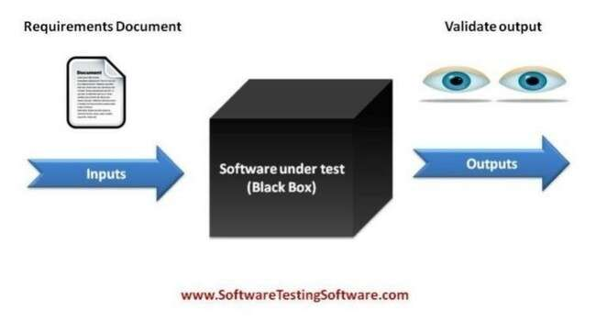

Fig. 17: Black Box

### The "black box Knocking" approach to software Knocking, also known as "functional Knocking," reveals just the system's functionality and design while concealing its basic implementation/structure. The system's internal code or structure are unknown to the person who will use it.

### **➢ Log In Segment**

|  |  |  |  |  |  |  |  |  |
| --- | --- | --- | --- | --- | --- | --- | --- | --- |
| **Project Name** | | SMART CITY | | |  | |  | |
| **Assessment Case ID** | | AC-001 | | | **Knocking Case Name** | | Sign In | |
| **Knocking Priority** | | High | | | **Assessmenter** | | Originator | |
| **Knocking Date** | | 17 May, 2022 | | | **Knocking Duration** | | 2 Hours | |
| **Description** | | User authentication via email and password is the topic of this segment. | | | | | | |
| **Pre-Condition** | | The user must be signed up and have a working mail credientials. | | | | | | |
| **S. No** | **Assessment Step** | | **Assessment Data** | **Expected Result** | | **Actual Result** | | **Status** |
|  | First-class Log In  Button | | Button  Selection | Log In bustle to be displayed. | | Log in activity is displayed. | | Pass |
|  | Fill the mail credentials and click Log In button. | | User details and Log In  Button | If your mail credentials match what is in the database, the website should say "Login Successful" and the app dashboard should appear. | | The dashboard activity is opened, and a toast notification indicates that the login was successful. | | Pass |
|  | without entering an email or password, click the Sign In button. | | User details and Log In  Button. | Please enter the mandatory fields, should be stated on the screen. | | It should be noted on the screen to fill out the vital fields. | | Pass |
|  | Click Log In button after inward bound | | User details and Log In  Button. | There should be a notice saying "invalid email or | | There should be a notification that | | Pass |
|  | invalid mail credentials. | |  | password.” | | “Invalid mail credentials.” | |  |
| **Post-Condition** | | The user gets logged in to the system. | | | | | | |

Table 42: Black Box Knocking of Log in Segment

### ** Registration Segment**

|  |  |  |  |  |  |  |  |  |
| --- | --- | --- | --- | --- | --- | --- | --- | --- |
| **Project Name** | | SMART CITY | | |  | |  | |
| **Assessment Case ID** | | TC – 02 | | | **Knocking Case Name** | | Registration | |
| **Knocking Priority** | | High | | | **Assessmenter** | | Originator | |
| **Knocking Date** | | 19 May, 2022 | | | **Knocking Duration** | | 2 Hours | |
| **Description** | | This segment deals with user registration before logging into the system. | | | | | | |
| **Pre-Condition** | | User must have the shop details in order to register. | | | | | | |
| **S. No** | **Assessment Step** | | **Assessment Data** | **Expected Result** | | **Actual Result** | | **Status** |
|  | Select Register  Button | | Button  Selection | Registration  Activity to  be displayed. | | Registration activity is displayed. | | Pass |
|  | Type in an existing email address and press the register button. | | User information and the Register button | The phrase "Email ID already exists" ought to be displayed. | | Email ID Exists | | Fail because the database's primary key must include the email ID. |
|  | | | | | | | | |
| **Post-Condition** | | A handler has been enumerated. | | | | | | |

### Table 43: Black Box Knocking of Registration Segment

**8.9 Conclusion**

The path found by the assessmenter when utilizing the Control Flow diagram to assessment the code of the update profile segment is shown above. The specified paths are appropriate for segment execution. As a result, the trail and lucidity are correct in order to meet the necessities of the apprise profile segment.

## 8.10 Amalgamation Knocking

Amalgamation Knocking combines and integrates the various system segments or components to determine whether the segments work as intended or cause any problems after amalgamation. The following are the objectives of this Knocking:

* Each segment should be able to communicate with one another without losing data, and each segment should be able to run independently of the others.
* Unit Knocking should be done incrementally, starting at a lower level.

### **8.10.1 Technique used for Amalgamation Knocking**

Bottom-up amalgamation Knocking makes sure the simplest segments are built first and that the subsequent segments up to the "main" programme are unified and experienced one at a time.

.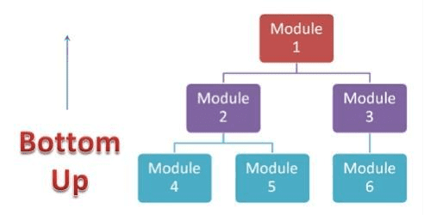

Figure 18: Amalgamation Knocking Technique

### **8.10.2 Validation for incorporation Knocking**

Amalgamation Knocking is relevant once the system's segments have all been independently examined by the originator. Following the Knocking of individual segments, the performance of the combined segments is assessed.

**8.11 System Knocking**

System Knocking is a technique for decisive whether a system operates correctly when all of its segments are combined into one system. In Knocking, the outcomes of the system or submission that was produced are compared to the requirements that were provided.

**8.11.1 Validation for System Knocking**

This kind of Knocking is carried out on the anticipated structure to make sure that, once all the segments have been put together and assessmented, the system as a whole operates as required and is error-free.

**8.12 Compatibility Knocking**

Compatibility Knocking is a type of non-purposeful Knocking that determines whether a system's hardware or software platforms are companionable. The Knocking makes sure that the finished programme or system functions impeccably across a number of platforms by taking into account the operating system, software, and hardware tools. This Knocking is done to see if the proposed system works in a specific setting that includes, among other things, hardware, software, a network, and an operating system.

### **8.12.1 Validation**

Dairy farms' online registration and processing system needs to be assessmented on a range of hardware and software platforms to make sure it works with each of them.

|  |  |  |  |  |  |  |
| --- | --- | --- | --- | --- | --- | --- |
| Project Name Dairy Made Easy | | | |  |  | |
|  | | | |  |  | |
| S. No **Knocking Method Expected Result** | | | | **Actual Result** | **Status** | |
| 1. | Hardware Assessment (As per the hardware requirement specified, Android Smartphone, | The app functions flawlessly, smoothly, and without any obstacles or problems. | The submission runs as Pass expected. | | |

RAM – 500MB, CPU

2.50Ghz).

|  |  |  |  |  |
| --- | --- | --- | --- | --- |
| 2. | Operating System Assessment | Because it is  a website designed for smart phone and PC’s. | For every operating system, the submission functioned flawlessly. | Pass |

### 3. Language Support

|  |  |  |  |  |  |  |  |  |  |  |  |
| --- | --- | --- | --- | --- | --- | --- | --- | --- | --- | --- | --- |
| 3.1. | Java | | The system must  installed | | have | | java | The run | submission Pass perfectly | | |
|  |  | |  | |  | |  | fine. |  |  | |
| 3.2. | | XML | | The system must have android Submission runs  set up. perfectly  without cavia any inconvenience. | | | | | | | Pass |
| 4. | |  | | **Development Platform** | | | | | | |  |
| 4.1. | | Android SDK | | The app should run perfectly fine  without any  intermission. | | Submission ran smoothly without  somewhat errors. | | | | | Pass |
| 4.2 | | Net Beans | | The system should run smoothly without any errors or exceptions. | | The submission worked fine. | | | | | Pass |

4.3 Firebase The submission should The

submission worked License runs perfectly without fine. any fault.

Table 45: Compatibility Knocking

## 8.13 GUI Knocking

Graphical user interface (GUI) Knocking is the progression of evaluating the system's GUI. It comprises putting to the assessment GUI controls like menus, buttons, icons, and various bars, including toolbars, menu bars, dialogue boxes, and windows.

Six design notions are used to assessment the system's GUI:

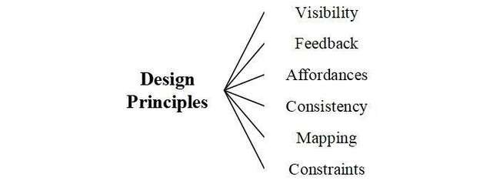

Figure 19: Design Philosophies to Assessment the GUI of the Website

### **8.14 Usability Knocking and its Validation**

* Usability Knocking is carried out to ascertain how comprehensible the system is to use and how simple and comfortable the system's interface is to use. It defines how simple or easy the system is to utilize for various users. Usability Knocking ensures that users of the system can operate it quickly, effectively, and easily. Users assessment the usability of a system via five Norms: user satisfaction, extensibility, learnability, and efficiency.
* Learnability is a statistic that appraises how easy it is for a user to use a system's interface or to accomplish a system's functionality. For instance, the suggested system has an intuitive user interface with forms, buttons, and other interactive GUI components, making it straightforward to learn
* Efficacy is a metric that measures how quickly a system can perform its functions and finish its duties. For instance, the system moves the user quickly and effectively from one action to the next.
* Exorability: This statistic appraises a system's end-ability users to recall the system's features when they come back to it after a long absence. For instance, the simplicity of usage and interface make it easy for users to utilize.
* Errors: This measure appraises the system's capacity for error recovery. The suggested system is error-free, and if an error did occur, toast alerts are displayed.
* **User Satisfaction:** This metric appraises how much a user enjoys or is satisfied with a system.

#### Rating Norms

|  |  |  |  |  |  |  |  |  |
| --- | --- | --- | --- | --- | --- | --- | --- | --- |
| **Excellent-5** | **Very-Good-4** | **Good-3** | | | **Average-2** | | **Poor-1** | |
| Table 47: Rating Norms for Usability Knocking  **Usability Knocking on the basis of five factors** | | | | | | |  |  |
| **Users Learnability Efficiency** | | | **I** | **Errors** | | **User**  **Satisfaction** | **Total** | **Average** |
| **Sakshi 5 5** | | | **4** | **4** | | **3** | **21** | **4.2** |
| **Niharika 5 5** | | | **3** | **5** | | **4** | **22** | **4.4** |
| **Nidhi 4 5** | | | **3** | **5** | | **5** | **22** | **4.4** |
| **Preethi 4 5** | | | **4** | **5** | | **5** | **23** | **4.6** |
| **Tanu 5 5** | | | **4** | **5** | | **4** | **23** | **4.6** |
| Overall Average: 4.44(88.80%); | | |  |  | |  |  |  |

Table 48: Usability Assessment

**8.14.1 User Reception Knocking**

A software Knocking method known as user acceptance Knocking (UAT) concentrates on the actual users of the proposed system or submission. To make sure the system meets the client's needs and is satisfactory, the originator must assessment it.

**8.14.2 Validation for UAT**

UAT's goal is to authenticate and atlas the specifications listed in the project requirements form to the project's structures so that the end user will accept it with ease.

User Acceptance Assessment It is performed following the originator's conclusion of earlier assessments. Finally, the UAT is completed to determine whether the originator met the user's prospects. A small group of individuals were chosen to assessment the submission, and the UT included the collection of their comments.

**8.15 Assessment Scheduled**

|  |  |
| --- | --- |
| **Name of the assessmenters** | **Knocking Date** |
| Abhinay | June 25, 2022 |
| Rinku | June 25, 2022 |
| Ravi | June25, 2022 |
| Yash | June25, 2022 |
| Sachin | June25, 2022 |

Table 49: Assessment Schedule for UAT

### **8.16 Citations Knocking**

This Knocking's goal was to demonstrate how accurate and full of information the paper is. To fully satisfy the project manager's demand, all important Norms must be satisfied, and the document must be well-presented. To guarantee that the Citations was thorough, the project manager established a 3rd Year Project Citations standard. The spell check function in MS Word helped with both grammar and spelling correction.

|  |  |
| --- | --- |
| Checking Norms from FYP | Status |
| **Referencing and excerpt has been done.** | Yes |

#### Ethical form is signed by supervisor. Yes

|  |  |
| --- | --- |
| **Citations sheets have proper enumeration, header and footer.**   * **Header: Kurukshetra University (LHS)** * **Project Title (Centre)** * **PIET Logo (RHS)** * **Footer: Roll Number (LHS)** * **Asia Pacific Institute of Information Technology (Centre)** ➢ **Page Number (RHS)** | Yes |

#### There are no implying mistakes in the citations. Yes

|  |  |
| --- | --- |
| **Citations has been verified with Viper.** | Yes |
| **Inquiry form have been defined why they have been used and a Validation is given for each particular question.** | Yes |
| **Credible internet references are used.** | Yes |
| **Must give orientation** | Yes |
| **Justify has been given why an approach, tool, languages, concept etc. was chosen.** | Yes |
| **Ethical Form has been included.** | Yes |
| **All the log sheets are attached.** | Yes |
| **“Originator” word has been used instead of word “I”** | Yes |

Table 50: Citations Knocking

### **8.17 Conclusion**

* Knocking enables programmers to provide software that lives up to prospects, averts unintended effects, and enhances the long-term functionality of the submission. If a originator wants to reduce outlays, time waste, and redraft while also increasing value, early Knocking is essential.
* Software Knocking has helped engineers find system flaws or problems, ensure the system's effectiveness and quality, and review and run code across numerous platforms and environments.
* The proper methodologies are used, such as the bottom-up organization for amalgamation Knocking, depending on the Knocking aim and the programme requirements. The system's functionality and logic have been assessmented via various Knocking methodologies at various levels. Black box Knocking was used to appraise the system's performance, whereas white box Knocking was used to assessment the logic of the system.
* The initial stage of Knocking, known as unit Knocking, examines each individual segment of the system both rationally and functionally. In order to verify the functioning of the segments and the code flow of the segments, assessment cases have been created. If problems or errors are found, these assessment cases will be used to determine how to proceed with removing them.
* When distinct segments have been thoroughly assessmented and are set to be further combined, amalgamation Knocking—a rational extension of unit Knocking—is conducted to see if any problems or errors arise as a result of the amalgamation. Because it helps identify issues when units are combined, amalgamation Knocking is simple to carry out after unit Knocking. Because he utilized a assessment plan that mandated that he assessment each unit and determine its feasibility before compounding them, the originator is aware that any problems discovered while merging units are most likely caused by the interface between units.
* Following amalgamation Knocking, system Knocking was carried out to find any issues that occurred when all of the units or segments were joined to form the system as a whole. Written and documented was a related assessment case. A compatibility assessment was performed on the system to see if it was compatible with the environment's hardware, network, software, database, operating system, or other tools or programme.
* The system's end users conducted usability and user acceptability Knocking at the conclusion to gather their comments, assess how usable it is, and determine whether it provides 100 percent user satisfaction. Because the system displayed user pleasure, error-free operation, efficiency, and memorability, it was considered to be usable. The system is now ready for deployment because user satisfaction has been obtained.

**8.18 CODE USED**

**CODE USED FOR REGISTER AND LOGIN INTERFACE CREATION**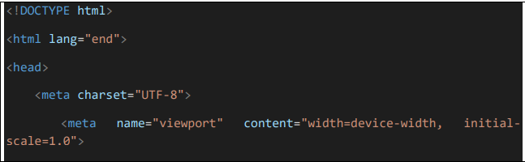

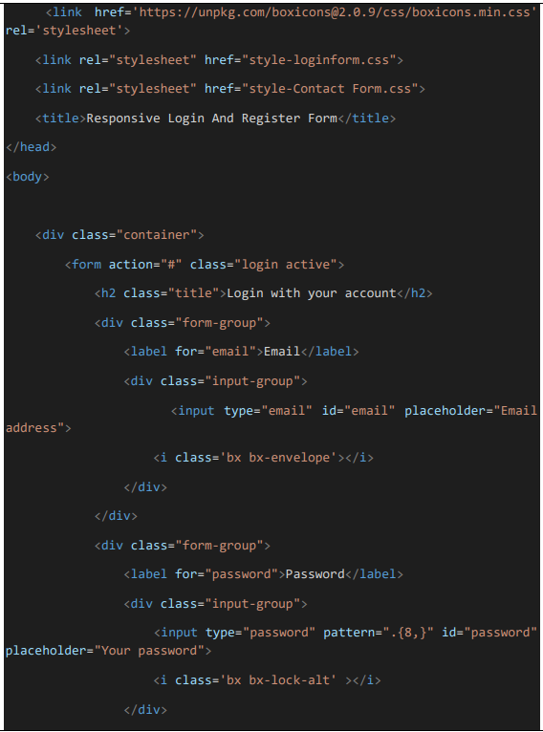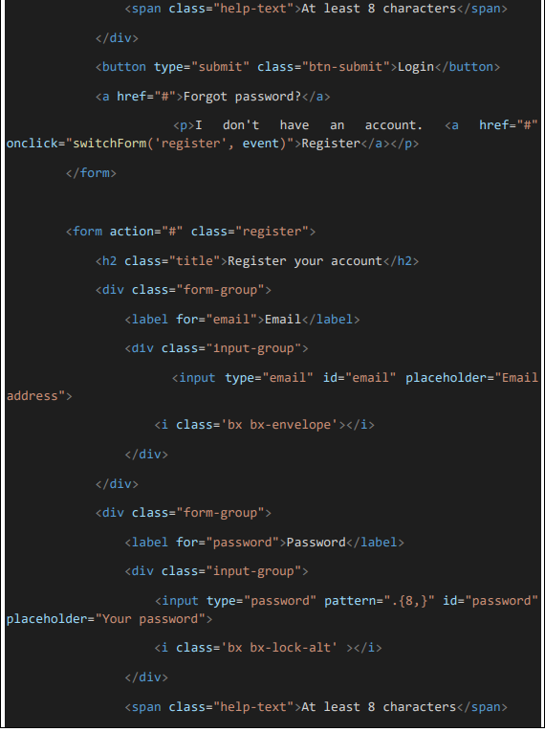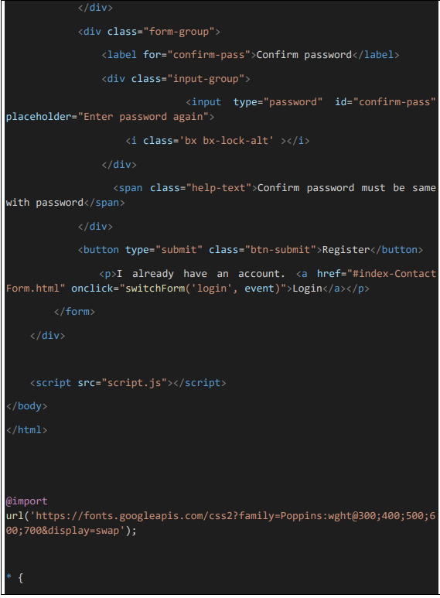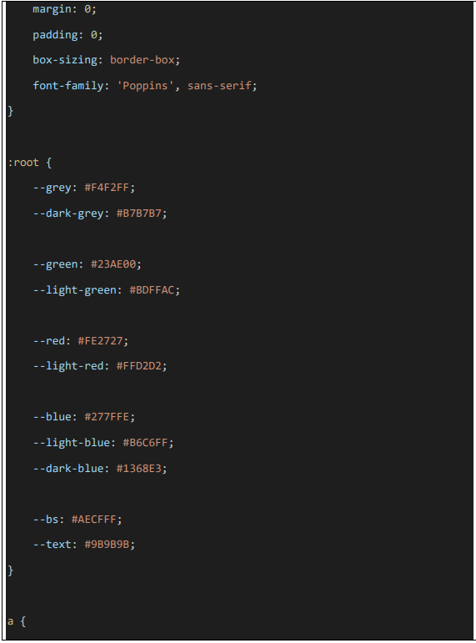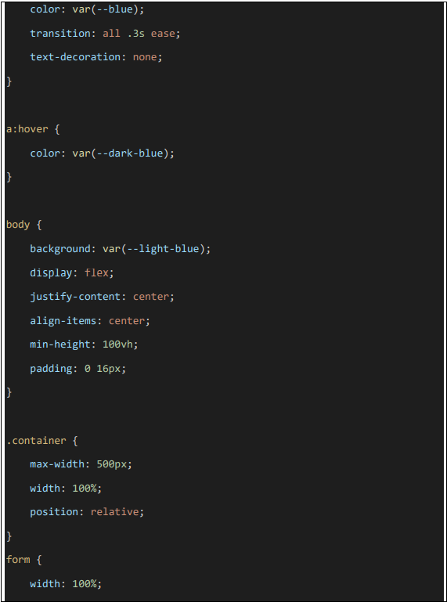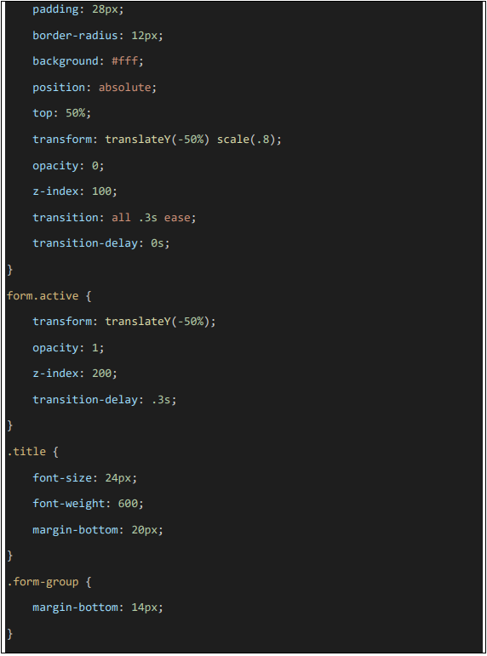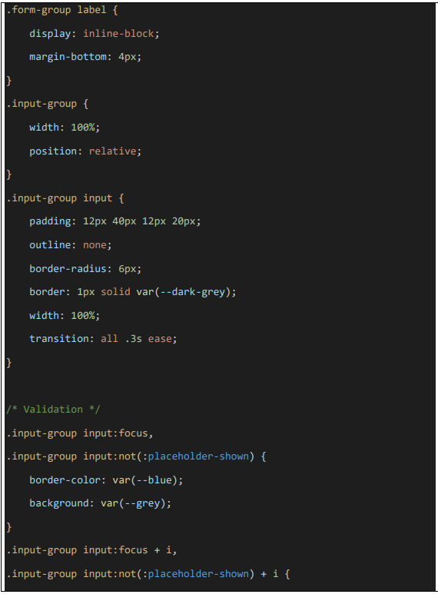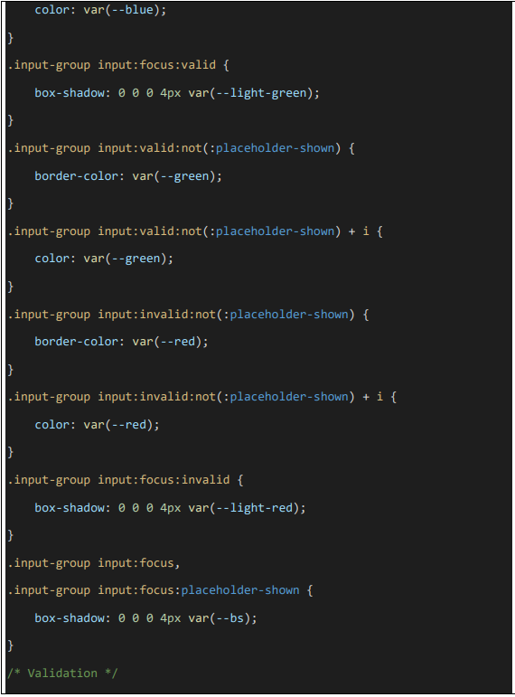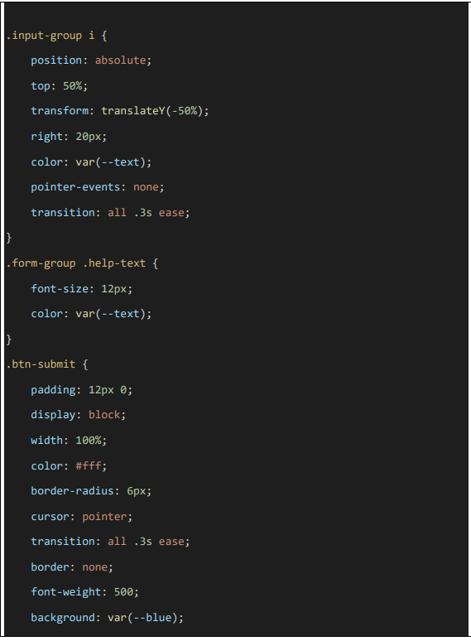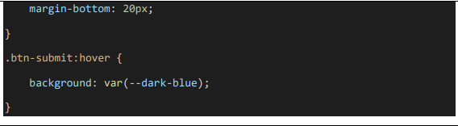

**Output**

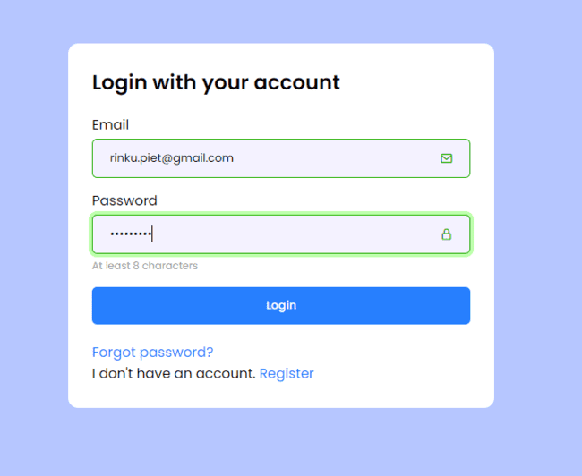

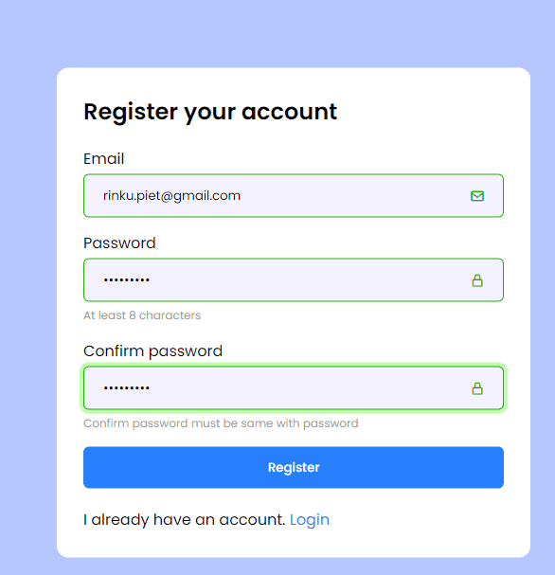

**CODE FOR SCRIPT VALIDATION FOR LOGIN AND REGISTRATION PAGE**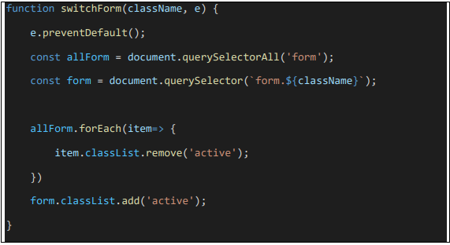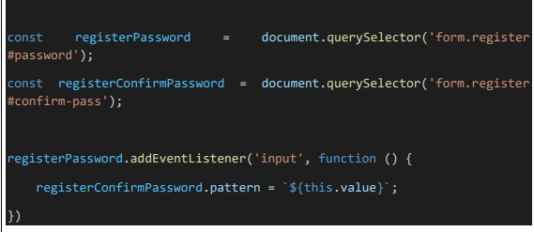

**CODE FOR DETAIL AND CITY SEARCH GENERATION**

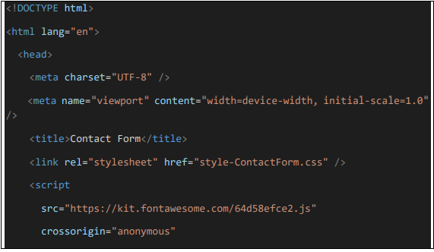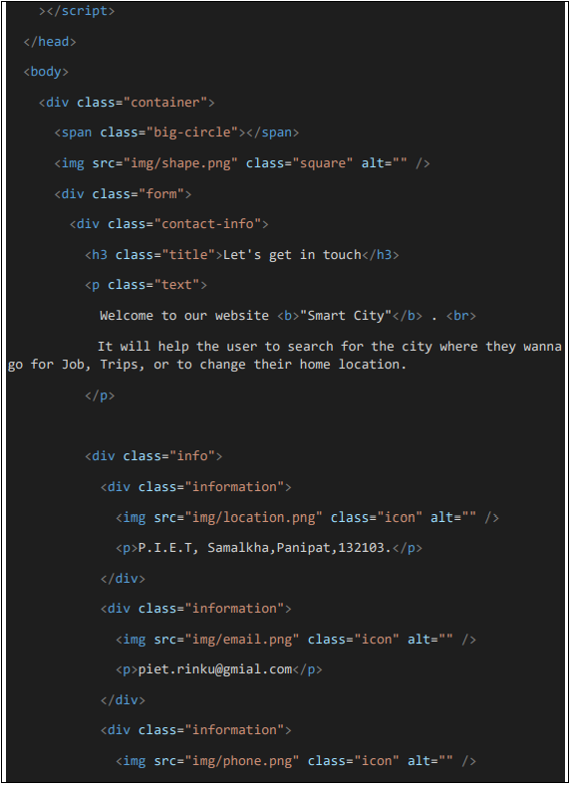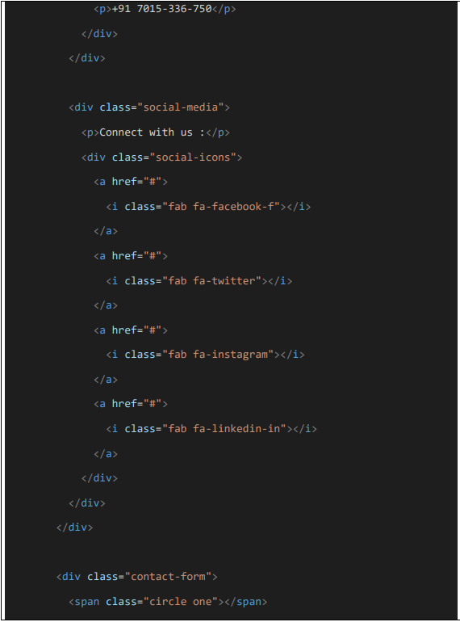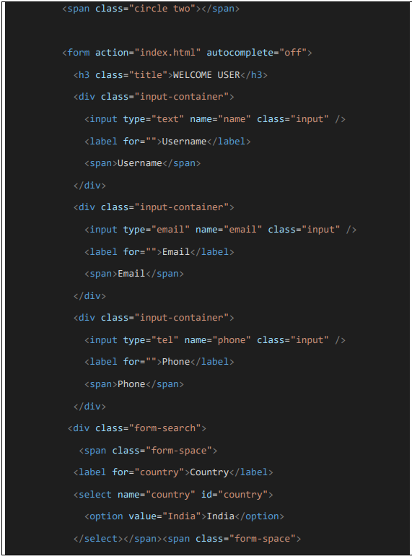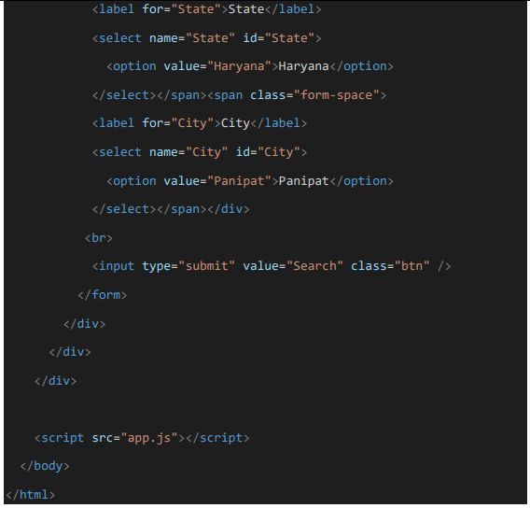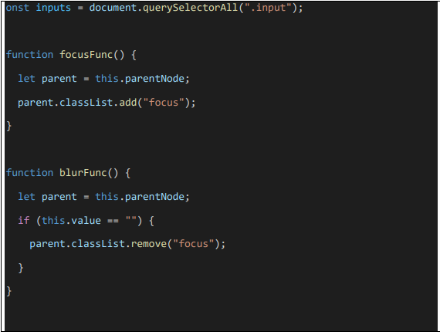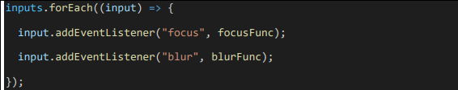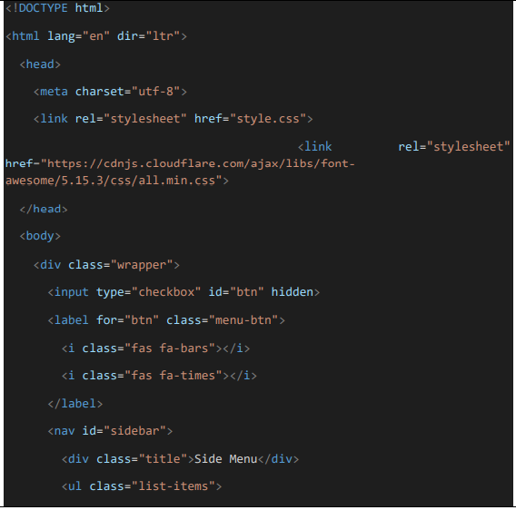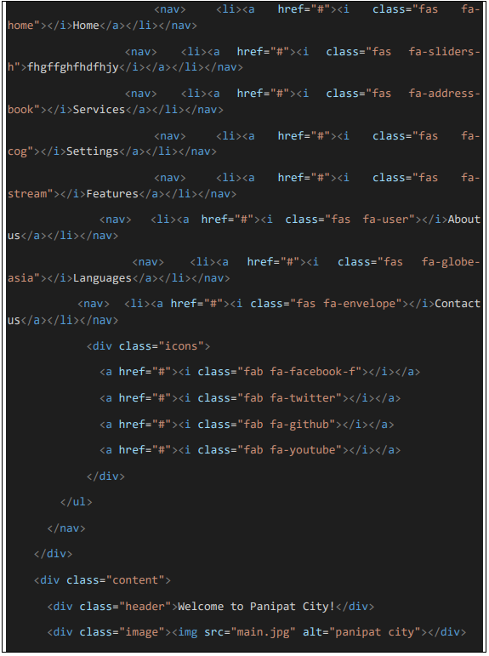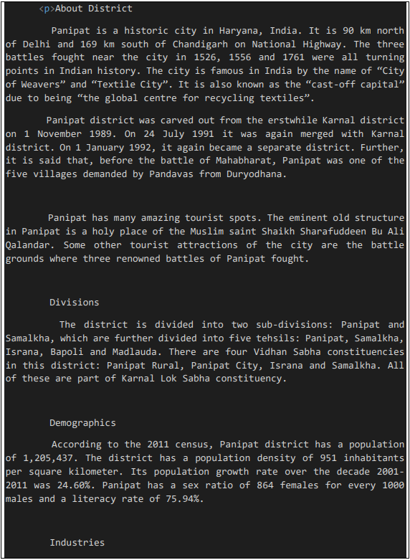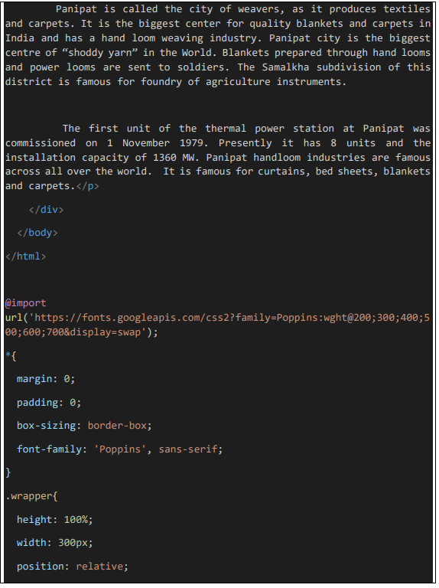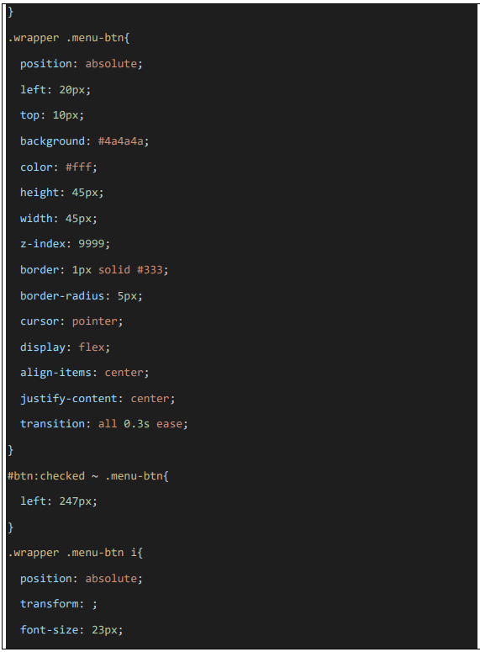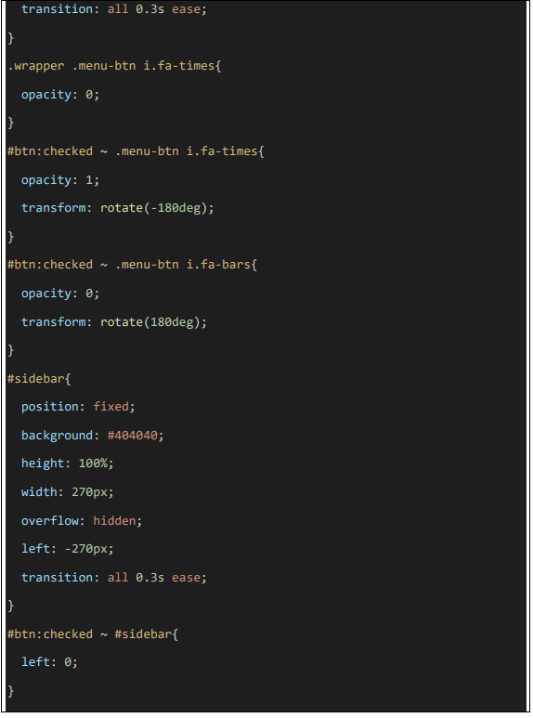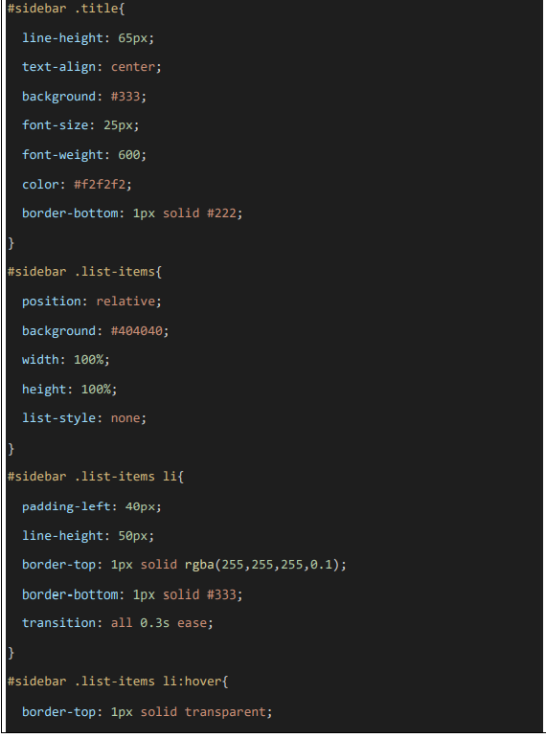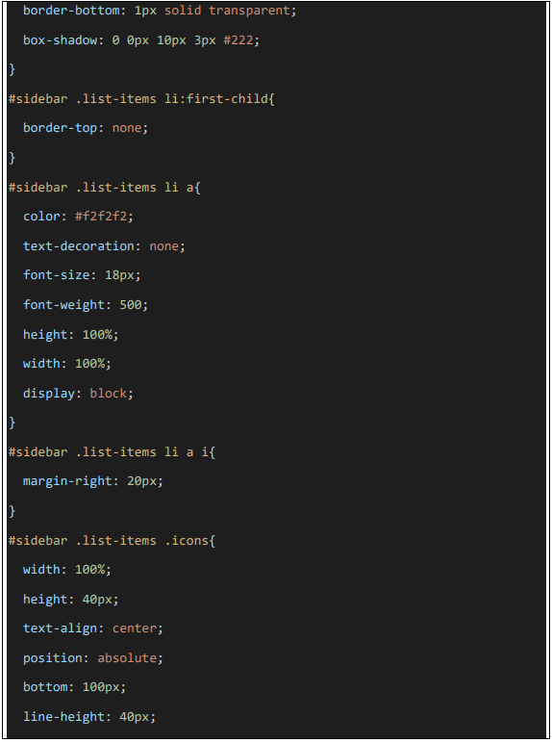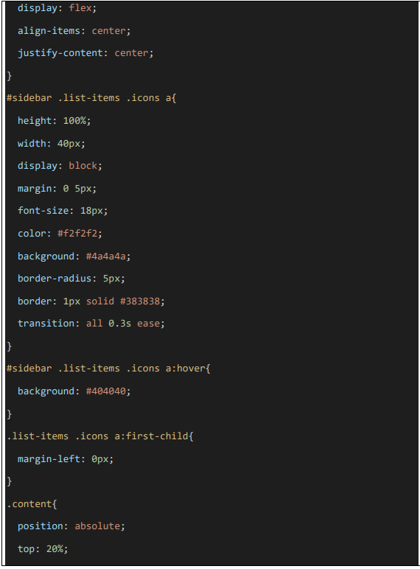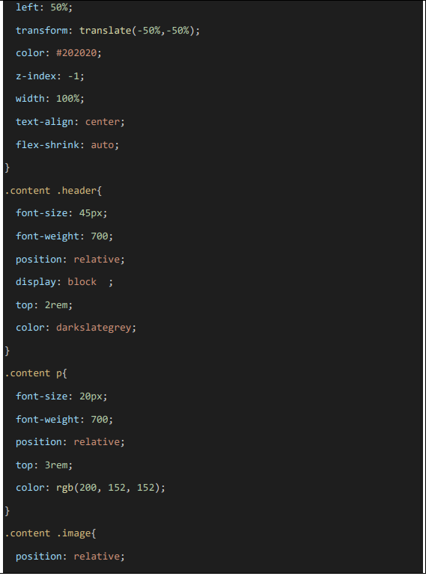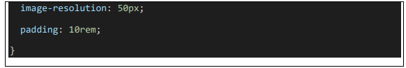

**Output**

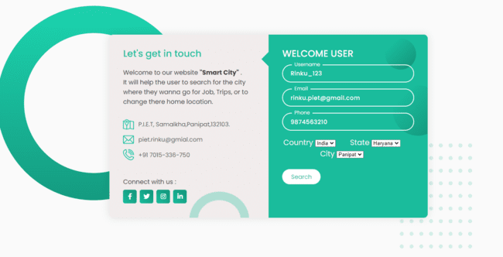

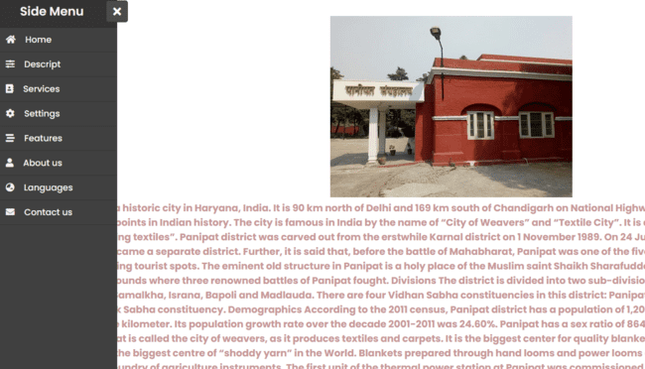

# **CHAPTER 9: CRITICAL EVALUATION**

## 9.1 Critical Evaluation

## After the proposed project has been completed, it is time to critically analyse it by comparing the characteristics supplied in the project's given specification form to the intended project and its requirements. The research was carried out by the originator to meet the requirements of the system capabilities. The originator developed such a system after extensive research and analysis, which will then be assessmented and implemented to recover from any default that may arise in the system, leading to a system free of bugs. Now is the critical moment to review the system, which includes a thorough assessment. Instead of evaluating each segment separately, the system's quality, relevance, and value are assessed as a whole.

## 9.2. Factors of Benefit (Usefulness of System to Target Audience)

Because it satisfies all needs and resolves all problems mentioned in the problem portrayal part of Chapter 2, this system is very helpful to mark users. The system's advantages were covered in section 1.7's discussion of real and hypothetical payoffs.

Here some of the benefits are listed below:-

|  |  |
| --- | --- |
|  | **Cost Efficient Benefits** |
| ➢ | This app is free of cost and user can access this app from anywhere without any inconvenience which would require little bit internet accessibility. |
| ➢ | Since, this app targets the users who are willing to buy and sell online dairy goods. Thus, it will save time, energy and money also. |
|  | ➢ **Mobility** |
| ➢ | As the use of mobile phones increases day by day, then this is a great advantage for users towards mobility. |
| ➢ | Entire submission works on mobile, so user gets a benefit of mobility while via this system. |
|  | **How to Enhance Merchandiseivity** |
| ➢ | The more the number of buyer and seller use this app for good; this will directly leads to increase the merchandiseivity in dairy management. |

Table 51: Factors of Benefits.

### **9.3.1 Degree of Success**

The degree of project success is determined by how the requirements for the proposed model are mapped in the project specification form. The system needs to adhere to the project development requirements, and deployment should be practical.

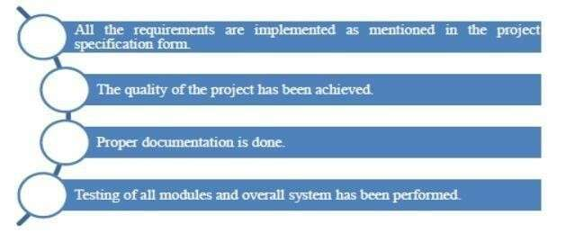

Fig 19: Degree of success

### **9.3.2 Critical Appraisal**

The originator made an effort to include all the recommended functionality into the final merchandise. The proposed Norms have been turned into a real-world system. Following the conclusion of the corresponding Knocking processes, a safe app is now ready for delivery. During the system development, many setbacks arose. The originator gave forth every effort to finish this segment as intended, was unable to do so due to technical and software difficulties (read Chapter 7). Originator has finished his part of the implementation but is now working on the same area as his research.

Other than that, the originator successfully satisfied all the functional and non-functional requirements, such as cleanliness, readability, and user interface. Along from just that, the project is taken thru the miles to use a wide range of real assessment cases to assure a genuine conclusion, evaluation, and feedback. The system that has been built is fully operational and ready to be used.

“SMART CITY**”** is the website that would have developed by the originators and no such system is available in the market with such features present till yet which have many functions and user friendly with searching for different locations.

# **CHAPTER** **10: CONCLUSION**

## 10.1 Success Norms

The suggested solution, called "SMART CITY," must be shown to be extremely beneficial to the end-user in order to satisfy all of the user's requirements as well as all of the quality and success Norms. The proposed system is effective because it fulfils the success Norms and performs the intended function. Both the difficulties and the suggested solutions for the problems raised in chapter two have been addressed by the system. The proposed system would successfully guarantee the end users' and checking in a real-time context, fixing the problem, according to an analysis.

**10.2 Limitations and Errors in the Developed System:**

* The features present in this Website are for android based mobile phones and all PC’s.
* This website will use internet for enabling GPS and for some of the functions.
* Users must have login to this system so that they can enjoy the features present in this app.

## 10.3 Future Improvement

* The website will be improved in the future by including personalization geographies so that users may tailor it to their needs.
* The website will be improved to enable several languages for users.
* Future improvements to the website are possible.
* The website may be improved to include a feature that permitss users to view ticket history after choosing a certain day from a calendar.

**10.4 What would have been done if given time to redo this project ?**

If the originator were given a second chance to work on this project, they would unquestionably improve the software inside.**Implementation of all functions in android mobile phone:** If the originator gets chance then originator will implement all features in mobile.

* **Connect with Google Map:** The time and distance of destination from the user’s location can be displayed on the map itself.

## 10.5 Computational Challenges

The key computational challenge in the system was applying handler, services, and automatic data updating in one go because the originator had to handle numerous errands at once, including:

➢ Attainment the GPS location takes between 5 and 10 seconds, so it is impossible for the originator to predict when he will receive the GPS location.

## 10.6 Gathered Learning Experiences

* **What is learned from research work:** In the beginning of the project, the originator wasn't clear what features the system should have. Because of this, the originator carried out secondary research by looking at the research papers of other writers and pointing out any mistakes they made. It helped with the development of in-depth subject knowledge as well as the critical evaluation of similar systems in terms of their advantages and drawbacks. Finally, in order to determine current user demands, the originator conducted primary research.
* **How to manage stress and save time:** As they progressed through the SDLC phases, originators took on a range of responsibilities, including those of analysts, researchers, database and mobile app originators, and assessmenters. The originator was able to significantly reduce stress and save time thanks to this.
* **Gained technical proficiency**: In addition to applying academic learning objectives, the system's deployment demanded a thorough understanding of a number of mobile technologies. To completely comprehend the principles of Android app development, multiple services, database notions, Web Services, and other challenges, it was crucial to read a variety of books and articles. In the end, it aided in improving technical knowledge and equipment mastery across a variety of languages, including, among others, Java, XML, and Android SDK.
* **What experience you get from this project:** With the help of this initiative, we have gained excellent business sense and skills. The originator played a crucial part in project management by meeting deadlines, transporting a quality system, adhering to user requirements, and via fact-finding procedures to gather demands. The Gantt chart was used on the way to divide the project into manageable errands and schedule its conclusion via the split-and-overcome method.
* **How an error gets resolved and what they taught us:** While building the system, the originator encountered a number of errors and exceptions, which he was able to resolve in a number of ways. This gave information on how to troubleshoot problems via a top-down strategy. Additionally, the originator gained the extremely special ability needed to create an error-free system: the ability to identify and fix faults.

## 10.7 Conclusion

The bookkeeping contains a account on the intended system as well as evidence on the system's progress through various development stages. The originator started by doing a system backdrop analysis, from which he deduced the difficulties that a customer would face when ordering dairy merchandises online in the current environment. The narrative reviews phase, which is a type of seek used to gather data in the current field of study in order to develop a successful system, follows the background study segment. Both primary and secondary seek were done by the originator. It was discovered that a number of steps were necessary for the originator to do in order to acquire the necessary understanding of this specific system. Data collection methods include interviews and surveys..

The originator was able to fully grasp the security measures employed by firms through the evaluation of the opinion poll, consultations, and focus groups because the manipulators came from a variety of trade sectors. Technical information was made accessible through consultations with software designers and originators. The rational and physical enterprises of the system are developed during the system design phase. Physical designs, entity relationship diagrams, UML diagrams, and other structures are divided up into these designs. The employment phase covers the originator's policy for developing various system segments, starting with the lowest-priority segments and working up to the highest-priority segments.